**CSC8002 – Big Data Management – Assignment 2**

Analysis of Covid-19 Mobility Data in Melbourne in 2020

Name: Diana Kither

Table of Contents

i) Introduction 3

ii) Data Exploration 3

iii) Literature Review 4

iv) Research Question 5

v) Data Analysis to Select Data Subset 6

vi) Database Design Based on the Subset Data 6

vii) Data Analysis 7

viii) Findings 12

ix) Ethics and Privacy 13

x) Database Access Details 14

xi) References 14

i) Introduction

The Google COVID-19 mobility data set was created to investigate changes in mobility of populations in various parts of the world during the COVID-19 pandemic (Google 2020). The data set contains the travel data of people to common locations collected from the location history of personal mobile devices (Google, 2020). Data was collected between February 15th 2020 and December 1st 2020 (Google, 2020). Numerous types of locations were grouped into categories including residential, workplace and retail. Daily movement data to these location categories was collected, combined and then compared to a baseline mobility value to determine the percentage change in movement of people to those locations as the pandemic progressed (Google 2020). Data was collected across multiple geographic regions in 135 countries around the world. This report will be focusing on data collected from Australia. Google has made the data set publicly available on the web and available for download at <https://www.google.com/covid19/mobility/>.

The COVID-19 pandemic has had devasting effects around the world. Social distancing and limiting movement are crucial elements in managing the spread of this highly contagious virus. Therefore monitoring movement data of the population to different types of locations is important with respect to managing Australia’s response to this pandemic. With our knowledge of population movement this information can then be used in conjunction with medical data enabling us to interpret types of locations where the risk of infection may be higher. In addition this information can also be used to assess the efficacy of movement restrictions in managing the spread of infection, develop recommendations to manage population movement, identify infection hotspots and in turn limit further infections in this pandemic and for disease control in the future.

ii) Data Exploration

The Google COVID-19 mobility data set is comprised of 234.1MB of data in a comma separated (.csv) file. For initial assessment of the data set, the data file was loaded into Jupyter Notebooks and analysed using Python. The data set contains 14 variables and 3,342,175 observations. For this report, only data from Australia was examined.

A total of 76,688 observations were collected in Australia, covering each state and territory in the country. Data was collected from February 15th 2020 till December 1st 2020. The six initial variables in the data set identify the location from which movement data was collected and are all categorical variables. The first two variables in the data set identify the country where the data was collected, by code and name respectively. The next two variables further identify the region within the country from which the data was collected. Sub_region_1 indicates the state or territory and sub_region_2 the council or shire within the state or territory. The variable metro_code is an additional location identifying variable however none of the data entries for Australia had values for metro_code. The variable Iso_3166_2_code represents the International Organisation for Standardisation (ISO) country and subdivision identification code, an internationally recognised code to identify countries and their regions (International Organisation for Standardisation, 2020). Again, no observations from Australia had an associated ISO code. The next variable, census_fips_code is a numeric code to identify states and counties in the United States of America so it is not applicable when considering Australian data. The variable date indicates the date that location data was collected. Data was collected daily.

The final six numerical variables measure the change in movement across six different categories of location, retail and recreation, grocery and pharmacy, parks, transit stations, workplaces and residential. Data was collected from a variety of location types and similar places were grouped together in each category however some locations may fall into more than one category (Google 2020). Each of these variables measures the percentage change in movement to that location category which is calculated daily (Google 2020). Movement to areas was measured from location data saved in the location history from individual mobile devices (Google 2020). This data was combined and then compared to a baseline movement value for that particular day of the week and a percentage change between the two values was calculated giving the percentage change in movement for that date for each category (Google 2020).

A baseline day value was calculated for each day of the week and was considered a typical movement value for that week day for each location category (Google 2020). This typical value was calculated from the median values for that week day from January 3rd 2020 till February 6th 2020 for the individual categories (Google 2020). Google (2020) also acknowledges that the baseline values do not consider periodic movement changes that may result due to seasons or other events.

iii) Literature Review

Since the release of the Google COVID-19 mobility data set, several studies have utilised this information to analyse the effects of population mobility and lockdown policies on managing the COVID-19 pandemic.

Yilmazkuday (2020) performed a study soon to be published in the Journal of Human Behaviour and Social Environment comparing international mobility data from the Google COVID-19 mobility data set with data of COVID-19 case numbers and deaths. The aim of this study was to investigate the relationship between COVID-19 infection rates and mobility changes as a result of lockdown restrictions (Yilmazkuday, 2020). Yilmazkuday (2020) used a difference in difference study design to investigate relationships between the two data sets across 130 countries from February to May 2020, making considerations for the effects of particular days, countries and timing of the hundredth COVID-19 case in each area. This analysis showed very positive results (Yilmazkuday, 2020). Yilmazkuday (2020) found that increased time at places of residence and decreased time in places outside the home including work, transit, retail and recreation locations all reduced rates COVID-19 cases and deaths. Furthermore increased time spent at places of residence had the greatest impact on COVID-19 statistics (Yilmazkuday, 2020).

Wang et al (2020) conducted a study using the Google COVID-19 mobility data set to investigate the relationship between changes in population mobility and COVID-19 infection rates across all states and territories in Australia. Mobility data from all regions in Australia was examined for a six month period from February 15th 2020 till August 15th 2020 (Wang, 2020). Furthermore Wang et al (2020) also went on to investigate the time delay between instituting lockdown measures and the point at which these restrictions start to affect COVID-19 infection rates. The study utilised Google COVID-19 mobility data and COVID-19 health data obtained from the Australian Department of Health (Wang et al 2020). Similarly to Yilmazkuday (2020), Wang et al (2020) also found that mobility restrictions had a positive effect on reducing the rate of COVID-19 infections in Australia. Wang et al (2020) also found that restrictions had a delay of between 7 and 14 days before their impact on COVID-19 infections was seen. Given the documented incubation period of COVID-19 of up to 14 days this result is to be expected (Wang et at 2020). In addition Wang et al (2020) also looked at mobility prior to the first and second waves of infection, focusing on Victoria and found the relationship between mobility and COVID-19 infection rates varied with area, time and mobility type, highlighting that other measures for preventing infection are also influencing infection rates in addition to mobility restrictions. Furthermore changes in some mobility types differed between Victoria’s first and second wave of infections (Wang et al 2020).

iv) Research Question/Selection of the Problem

After initial assessment of the Google COVID-19 mobility data set a research question was then selected for further exploration. Utilising this data set, I have chosen to examine the mobility data from the February 15th 2020 till December 1st 2020 for the area of metropolitan Melbourne with the aim to explore how this movement data changed through the first and second waves of infection and subsequently through the easing of restrictions after each lockdown to determine if any particular similarities or differences exist.

The city of Melbourne is home to approximately 4.9 million people and is comprised of 31 local council regions (Travel Victoria 2020). Melbournians experienced the longest and most stringent lockdown measures of all Australian cities after the outbreak of COVID-19 this year. As a result of these measures as well as other string hygiene and social distancing rules and recommendations, Melbourne has successfully managed a second wave of COVID-19 infections and as of December 19th had reached a total of 50 days in a row with no new locally acquired COVID-19 cases, classifying the city as having eliminated the virus (Covidlive, 2020). Given the subsequent waves of infection being experienced in other parts of the world how did mobility influence Melbourne’s success in managing the spread of COVID-19 after its second wave. The study discussed earlier by Wang et al (2020) examined data trends from each state in Australia and highlighted some interesting findings about mobility changes in the state of Victoria at the commencement of the first and second waves as discussed earlier. As a Melbourne resident myself, I am keen to investigate the mobility trends in our city during COVID-19 during the periods lockdown and of easing of Melbourne restrictions to determine if any interesting patterns exist between the two waves of infection and now.

Given the contagious nature of the COVID-19 virus, mobility data can provide useful insights into the effect of movement and implementation of restrictions on managing the spread of COVID-19 which is valuable information for policy makers managing Australia’s response. In particular to the research question discussed above, comparison of mobility data between lockdown and the easing of Melbourne restrictions for the first and second time may also provide valuable insights into aspects of population mobility that may have influenced the second wave of infection and also the recent success we are currently experiencing here in Melbourne in managing the outbreak of COVID-19. This in turn can aid with future decision making with respect movement restrictions and other policy measures for management of this current pandemic in both Melbourne and the rest of Australia but also for disease control in the future.

v) Data Analysis to Select Data Subset

The Google COVID-19 mobility data set was analysed and then a subset of the data containing the mobility statistics for the city of Melbourne was selected to investigate the research question. The data set was analysed in Jupyter notebooks using Python and the code can be found in the file *subset_dataselection.ipynb*. The data set was loaded into Jupyter notebooks and the Australian data was selected based on the variable country_region. Any columns containing no data were then removed as these variables would not be relevant to the data subset which resulted in dropping the variable metro_area. Unique values where then explored in the variable sub_region_1 to determine how the location of data was further described. Sub_region_1 divided data into states and territories of Australia. Victorian data was selected and contained a total of 17,853 entries. The data subset was refined further by removing additional variables that were not required. These included country_code and country_region as the value for these variables is the same for all Victorian entries. Iso_3166_2_code was removed as again this value also represented the country and state from which data was collected and therefore was not relevant for this analysis. The remaining data subset then contained eight variables.

As Melbourne data is required for the research question, the variable sub_region_2 was then explored for its unique values to determine how the location of data in the data subset is further described. Sub_region_2 represents the local council region from where data was collected. Data was then selected from the current data subset for each of the 31 municipal councils that form metropolitan Melbourne. This final data subset for the city of Melbourne is comprised of 8708 entries and 8 variables. These 8 variables represent the council jurisdiction in Melbourne where data was collected, the date on which data was collected, and the percentage change in mobility for each of the six categories on that day, retail and recreation, grocery and pharmacy, transit stations, parks, workplace and residential.

vi) Database Design Based on the Subset Data

After selection of the Melbourne data subset a NoSQL database in MongoDB was constructed using Python to store the data and to enable information to be easily accessible for further analysis to investigate the research question. The code for building the database can be found in the file *subset_nosql_database_creation.ipynb.* The database named melb_covid contains six collections with each collection representing each category of the mobility data, retail and recreation, grocery and pharmacy, parks, transit stations, workplaces and residential. Each collection contains the date, council jurisdiction and percentage change in mobility for that category on a particular day. Null values were removed from each category data set prior to creating database collections. Each collection is connected with one another due to commonality of the location variable sub_region_2 between all collections. A diagram of the database schema is shown in Figure 1 below.

*Figure 1: melb_covid Database Design*

The research question being explored investigates the change in mobility to six different location categories in the city of Melbourne across the first and second lockdowns to investigate any significant patterns that may emerge. The Melbourne data set contains almost 9000 entries. Thus by separating data into collections representing each individual location category enables data to be easily accessed for each group which assists further data analysis for mobility changes which can then be compared between groups.

vii) Data Analysis

Mobility data for the city of Melbourne was analysed using Python to compare the changes in movement between the first and second lockdown periods during the COVID-19 pandemic. The code for analysis can be found in the file *code_for_analysis.ipynb.* Six mobility categories were examined, retail and recreation, grocery and pharmacy, transit stations, parks, workplace and residential. The percent change in movement from baseline was measured daily for each of these categories in each council region of Melbourne. For data analysis, data from each of these groups was selected from the database and divided into two time periods, the first ranging from February 15th, 2020 till June 30th, 2020 and the second from July 1st, 2020 till December 1st , 2020. The first lockdown period in Melbourne commenced on March 19th, 2020 with the first stage of lifting of restrictions beginning on June 1st, 2020 (Wallquist 2020). The second lockdown period commenced on July 7th, 2020 with stage 4 restrictions beginning on the August 4th, 2020 and finishing on October 28th, 2020 (BBC 2020, Handley 2020). Mask wearing became mandatory in Melbourne on July 23rd, 2020 (Handley 2020). The two time periods analysed were selected to compare movement between the two lockdown periods and the subsequent easing of restrictions. Given that movement data was collected from a total of 31 council regions in Melbourne this data was then grouped together for each date and an average percent change in movement from baseline was calculated. This resulted in an average percent change in movement for each category for the city of Melbourne for each day. Descriptive statistics were then calculated for each category in both time periods and movement changes were also plotted graphically against time for visual analysis. The first movement category examined was that of retail and recreation. This category not only includes movement to retail areas and shopping centres but also cafes and restaurants. Graphs of percent change in movement for each time period are shown below.

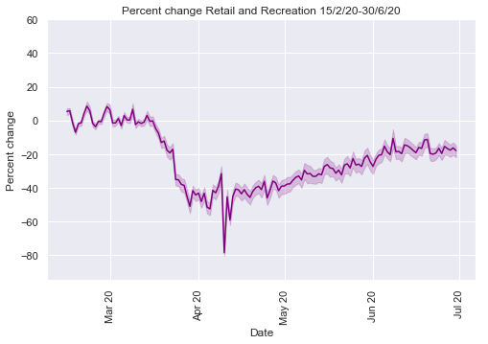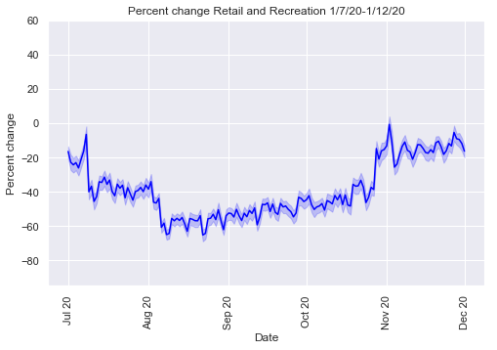

*Figure 2 – Percentage Change in Movement to Retail and Recreational Areas in Melbourne 15/2/20-1/12/20.*

As seen in the graphs above there was a significant drop in movement to retail and recreation areas during lockdown, more so in the second lockdown due to closing of all non-essential stores with stage 4 restrictions at the beginning of August. The mean percentage change in movement for the second lockdown was greater than the first at -38.83% compared to -23.22%. The level of movement to retail and recreational areas was similar after the easing of restrictions from both lockdowns with the increase being slightly higher after the second lockdown. Interestingly the greatest decrease in movement occurred during the first lockdown in early April at 78.83% which likely coincided with the Easter long weekend.

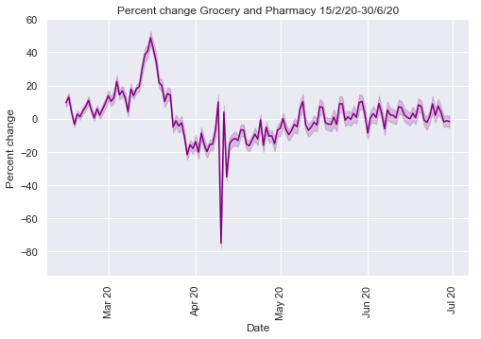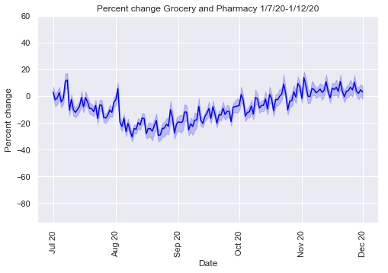

*Figure 3 – Percentage Change in Movement to Grocery and Pharmacy in Melbourne 15/2/20-1/12/20*

Movement for grocery and pharmacy was generally at similar levels during both lockdowns. Average daily movement was increased by just 1% in the first lockdown however had decreased slightly by 8% in the second lockdown. Movement was also similar with the easing of restrictions after both lockdown periods and with no great changes from normal levels. Some exceptions in this trend however where in the middle of March were movement increased by 48% likely secondary to panic buying prior to the first round of restrictions and then in April had decreased by 75% around Easter.

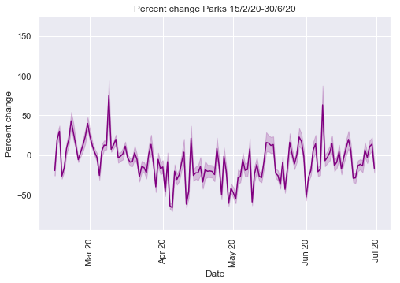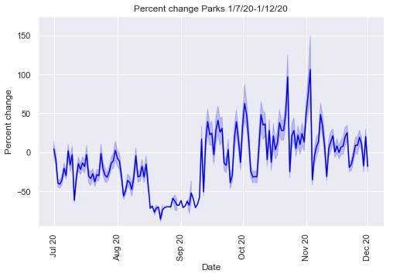

*Figure 4 – Percentage Change in Movement to Parks in Melbourne 15/2/20-1/12/20*

The next category of parks included movement to parks, national parks and public beaches. Movement to parks varied across the two time periods likely secondary to the level of exercise and travel restrictions and also season. Movement was increased by 74% just prior to the first round of restrictions likely due to good weather and the Labour Day Long weekend in March. Mobility levels then varied between approximately 20% and -50% during the first lockdown before increasing again as the first round of restrictions lifted. Levels again reduced similarly at the commencement of the second lockdown before decreasing further at the start of stage 4 restrictions to 85% below baseline. Movement levels then increased significantly as restrictions eased after the second lockdown with the introduction of rules allowing picnics and with improvement in weather after winter likely to also have contributed to this change. Movement increased to a maximum of 106% above baseline in early November.

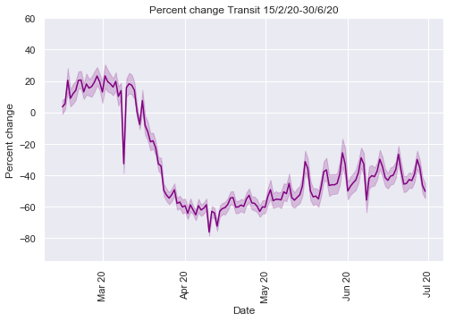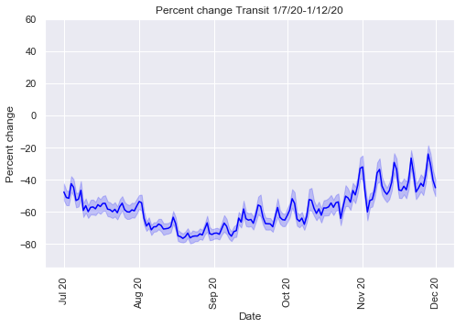

*Figure 5 – Percentage Change in Movement to Transit Stations in Melbourne 15/2/20-1/12/20*

Movement to transit stations declined significantly at the start of the first lockdown with movement trends appearing similar during and after the first and second lockdowns. The average reduction in mobility to transit stations in the first lockdown was 34% and in the second lockdown 58%. However despite the easing of restrictions after both lockdowns movement to transit stations is still significantly decreased at 20% to 40% below baseline levels, likely due to a significant number of commuters still working from home. Regular fluctuations are likely the result of the difference in travel on weekdays compared to weekends.

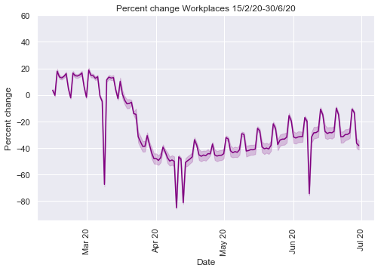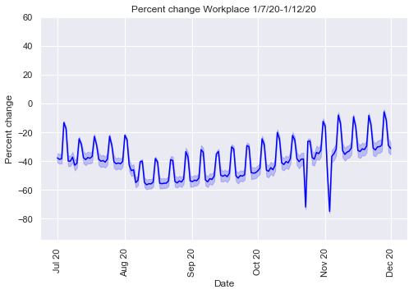

*Figure 6 – Percentage Change in Movement to Workplaces in Melbourne 15/2/20-1/12/20*

Due to the marked change of many workplace environments to working from home with the pandemic, movement to workplaces across the two time periods is significantly reduced. The average reduction in movement to workplaces for the first lockdown period is 25% and for the second 38%. Significant reductions in workplace movement in March, April and June are likely secondary to Labour Day, Easter and Queen’s birthday long weekends. Changes in October and November are likely due to the Grand Final public holiday and the Melbourne Cup Day long weekend. Weekly fluctuations are likely influenced by those workers who are still required to travel to their workplaces. Again movement to workplaces increased after both lockdowns to similar levels however were still approximately 10%-30% below baseline.

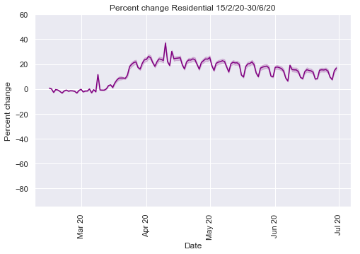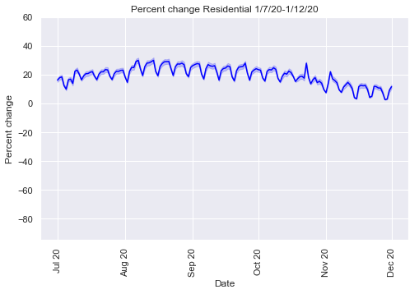

*Figure 7 – Percentage Change in Movement to Places of Residence in Melbourne 15/2/20-1/12/20*

The last collection of data examined was for mobility to places of residence. As seen the percentage of time spent at home increased as would be expected with lockdown restrictions and working from home. The average percentage movement increase from baseline was 13% in the first lockdown period and 19% in the second likely influenced by increased restrictions during the second lockdown. Regular fluctuations in movement to residences are likely due to people who were still required to travel to workplaces and as well as movement for other essential tasks such as grocery shopping and exercise. There is also an increase in time spent at home around the Easter long weekend. As restrictions eased between the first and second lockdowns there was a decrease in the amount of time spent at home before it increased again with commencement of further restrictions and curfews in August. Time spent at home then decreased again with the easing of the second lockdown reducing to an almost 0% change from baseline in November. With the lifting of travel restrictions to regional Victoria, the improvement in the weather and Christmas approaching this is expected.

The goal of this report was to compare mobility trends between the first and second lockdown periods and subsequent easing of restrictions in Melbourne to see if any differences were evident particularly just prior to Melbourne’s second wave of COVID-19 infections and now. Generalised movement was decreased during both lockdowns and infections rates reduced significantly, particularly after the second lockdown which highlights that reducing population movement does help prevent the spread of COVID-19 (Wang et al 2020, Yilmazkuday H 2020). Levels of movement in all categories outside of the home increased subsequent to both the first and second lockdowns however only grocery and pharmacy returned to pre pandemic levels. Furthermore mobility trends across all categories except for parks were similar across the first and second lockdown periods with these categories reaching similar mobility levels after the easing of restrictions for the first and second time. Restrictions were increased during the second Melbourne lockdown compared to the first resulting in further reduction of population mobility as seen in the data when comparing the two time periods. Given Melbourne’s current success in managing the spread of COVID-19 after the second lockdown despite similar levels of movement as restrictions have eased after both lockdowns highlights that these greater restrictions appear to have had a positive effect.

The study by Wang et al (2020) highlighted variable relationships between mobility types and infection rates at the commencement of Victoria’s first and second waves of COVID-19 indicating that other methods of infection control in addition to mobility restrictions are also influential in managing the spread of COVID-19 as would be expected given the multifactorial nature of infection control. Mobility was increasing in Melbourne prior to the second wave of COVID-19 however was still below pre-pandemic levels as the second wave commenced indicating the influence of other factors on infection control (Wang et al 2020). The effect of the second wave and further restrictions on these other important aspects of infection control, including hygiene, social distancing, personal behaviour and other government initiatives including mask wearing will all have had an effect on management of COVID-19 spread after the second wave in addition to reductions in mobility.

Furthermore another key difference between the timing of the first and second waves in Melbourne and now is season. Melbourne’s second wave began in winter with the easing of restrictions after the second lockdown starting in spring and summer. So again despite the increase in mobility and similar mobility patterns after the first and second waves, infection rates are currently still well managed which raises the question does season have any influence on the spread of COVID-19 infections however this is not yet known (Lawton 2020).

The movement to parks and other outdoor areas has also increased after the second lockdown however unlike other categories to much greater levels than prior to the pandemic. In addition the movement to parks varied between the first and second lockdowns with a similar pattern of movement from the start of the first lockdown till stage four restrictions commenced where movement decreased further. From there movement subsequently increased towards the end of the second lockdown and easing of restrictions to greater than pre pandemic levels. During this time the weather in Melbourne had improved with spring and also picnics were permitted outside with limited numbers of people leading to increasing amounts of time being spent in parks. Risks of infection are believed to be lower outside with greater ventilation and larger spaces for social distancing which may have influenced reduced infection rates despite movement increases to these areas (CDC 2020). Furthermore as discussed above other hygiene measures and personal behaviour again also would also have had a positive effect on infection control (Wang et al 2020).

viii) Findings/Conclusion

Decreasing population mobility did show to have a positive effect on controlling COVID-19 infections during the first and second waves of the pandemic in Melbourne. Given the success of managing Melbourne’s second wave of COVID-19 through greater restrictions which further reduced population mobility also appears to have had a positive effect on infection control. Mobility patterns were shown to be not dissimilar after the easing of restrictions from the first and second lockdowns across several categories highlighting that other measures of infection control including hygiene, social distancing, mask wearing, personal behaviour and other government initiatives have also influenced the success of managing the COVID-19 pandemic in Melbourne (Wang et al 2020).

ix) Ethics and Privacy

With the explosion of information available to us from data, we have an abundance of material from which we can gain beneficial knowledge that can aid decision making. However maintaining user privacy and utilising this information ethically is of paramount importance (Lee et al 2016). Data usage is also governed by standards and legislation and it is imperative that these guidelines are adhered to (Lee et al 2016). When using the Google COVID-19 mobility data set considerations in relation to both privacy and ethics whilst using this information are imperative. Data collection is legislated by Australian Privacy Law. Australian privacy law dictates that an organisation can only collect data that is directly in relation to its activities, the identification of a person must be protected, a person must consent to having data collected and the information must be collected lawfully and directly from that person (Australian Government, 2018). In permitted health situations the law does account for exemptions for collecting data that may be necessary for public health and safety without an individual’s consent (Australian Government, 2018).

The Google COVID-19 mobility data set was created from data stored in the location history of personal mobile devices (Google 2020). Location data is collected by Google for various services including Google Maps (Google 2020). This data was obtained anonymously and combined so as no personal individual information is disclosed and to limit any identifiable data. Google (2020) utilises differential privacy techniques to prevent identification of individuals from collected data. Furthermore Google (2020) also acknowledges if low levels information were obtained from particular location areas, this information was excluded from the data set to reduce the risk of individuals being identified. Data was also collected with consent of the user given through turning on location services on a device (Google 2020). Google also acknowledges that the default setting for location services is off, therefore the user has to actively give consent for data usage by turning on location services. The user also has the option to clear or delete their location history at any time (Google, 2020)

Using data ethically is also of huge importance, information must be used in an honourable way and the effect of using data must be considered for all parties involved (Lawler, 2019). Given that individuals are giving consent for data to be collected through Google location services and that data is being used for an important cause and not maliciously is essential in ensuring this information is used in a proper way (Lawler, 2019).

x) Database Access Details

BONUS - Access details for NoSQL database in AWS cloud

Public URL: ec2-54-163-49-32.compute-1.amazonaws.com

Port: 443

Username: diana

Password: diana

xi) References

1. Australian Government (2020), ‘*Guide to Data Analytics and the Australian Privacy Principles’* web article, 21st March, Office of the Australian Information Commissioner - Australian Government, Sydney, Australia, viewed 14th January 2020, <https://www.oaic.gov.au/privacy/guidance-and-advice/guide-to-data-analytics-and-the-australian-privacy-principles/#s2-2-collection-of-personal-information-app-3>

2. BBC, 2020 *‘COVID in Australia: Melbourne to exit 112 day lockdown’*, web article, 26th October, BBC News, London, viewed 10th January 2020, <https://www.bbc.com/news/world-australia-54686812>

3. Centre for Disease Control and Prevention (2020), *‘Deciding to Go Out’* web article 28th October, Centre for Disease Control and Prevention, Atlanta, Georgia, viewed 14th January 2021, <https://www.cdc.gov/coronavirus/2019-ncov/daily-life-coping/deciding-to-go-out.html#:~:text=COVID%2D19%20spreads%20easier%20between,people%20apart%20are%20more%20risky>.

4. Covidlive (2020), ‘*Covidlive’,* Australia, viewed 19th December 2020, <<https://covidlive.com.au>>

5. Google 2020, *Community Mobility Reports Help*, Google, California USA, viewed 13th December 2020, <<https://support.google.com/covid19-mobility#topic=9822927>>

6. Handley E 2020, *‘Melbourne was meant to emerge from stage 3 restrictions today. Where are we now?’*, web article, 20th August, ABC News, Melbourne, viewed 10th January 2021, <https://www.abc.net.au/news/2020-08-20/victoria-coronavirus-meant-to-emerge-stage-3-where-are-we-now/12575678>

7. International Organisation for Standardisation (2020), *‘Popular Standards – ISO 3166 Country Codes’*, International Organisation for Standardisation, Geneva, Switzerland, viewed 13th December 2020, <<https://www.iso.org/iso-3166-country-codes.html>>

8. Lawler B, 2019 ‘Five Global Trends in Data Ethics and Privacy in 2019’ *Looker*, weblog, 28th January, viewed 19th December 2020, <https://looker.com/blog/big-data-ethics-privacy#:~:text=Data%20privacy%20is%20responsibly%20collecting,based%20on%20your%20brand%20values>

9. Lawton G 2020 ‘Will the spread of COVID-19 be affected by changing seasons?’ web article, 1st April, *New Scientist,* London UK, viewed 14th January 2021, <https://www.newscientist.com/article/2239380-will-the-spread-of-covid-19-be-affected-by-changing-seasons/>

10. Lee WW, Zanki W, Chang H, 2016 ‘An Ethical Approach to Data Privacy Protection’, *ISACA Journal,* Vol 6, pp 1-9

11. Travel Victoria 2020, *‘ Metropolitan Councils’* Travel Victoria, Victoria, Australia, viewed 17th December 2020,<https://www.travelvictoria.com.au/victoria/metropolitancouncils/>

12. Wang S, Liu Y, Hu T, 2020, ‘Effect of the Change of Human Mobility Adherent to Social Restriction Policies and its Effect on COVID-19 Cases in Australia’, *International Journal of Environmental Research and Public Health*, Vol 17, No 21, pp 7930 - 7946

13. Wallquist C, 2020 *‘Australia’s Coronavirus Lockdown – the first 50 days’*, web article, 2nd May, The Guardian, Sydney, viewed 10th January 2020, <https://www.theguardian.com/world/2020/may/02/australias-coronavirus-lockdown-the-first-50-days>

14. Yilmazkuday H (2020) ‘Stay at Home Works to Fight Against COVID-19: International Evidence from Google Mobility Data’, *Journal of Human Behaviour in the Social Environment,* Forthcoming, <<http://dx.doi.org/10.2139/ssrn.3571708>>